**Junior Chamber International Queensway**

**Member Handbook 2023**

Table of Contents

**1. President Message 4**

**2. Introduction of Junior Chamber International 5-7**

2.1 JCI Creed, Mission and Vision 5

2.2 JCI History 5

2.3 2023 President 6

2.4 JCI International Events 6

2.5 JCI Corporate Slogan 6-7

2.6 JCI Opportunities 7

2.7 International Co-operation 7

**3. Introduction of Junior Chamber International Hong Kong (JCIHK) 8-21**

* 1. History of Junior Chamber International Hong Kong 8-15
  2. Past National Presidents 15-17
  3. 2023 National President 17
  4. JC Abbreviation 18-19
  5. Junior Chamber International Hong Kong 21 Chapters 20-21

1. **Introduction of Junior Chamber International Queensway (JCI Queensway) 22-29**
   1. Organization Chart of Junior Chamber International Queensway 2022 25
   2. Year Plan of Junior Chamber International Queensway 26
   3. Past Presidents and Ex-NAEO List of Junior Chamber International Queensway 27 -29
   4. 2023 President 29
2. **JCI Queensway Member Guides 30-42** 
   1. How to become a member? 30
   2. Member's Career Path 31-35
   3. Quick Manual on Member’s QJC Mail Set-up 36-39
   4. QJC and JCIHK Calendar Subscription Quick Manual 41
3. **Project Guides. 43-55**
4. 1. Duties of Organizing Committee (OC) 43-44
   2. Parliamentary Procedures 44-55
5. Conduct of Meeting 44-45
6. Agenda 45
7. Rules of Procedure 45-49
8. Standard Format of OC Meeting Agenda 50-52
9. Standard Format of OC Meeting Minutes 53-54
10. Standard Format of OC Report 55

### 1. President Message



Message from President Queensway

On behalf of JCI Queensway, I would like to extend my heartfelt congratulations to National President Senator Kenneth Yu and his National Board of Directors on this special occasion of JCI Hong Kong Inaugural ceremony.

“Lead to Impact” is the theme of JCI Hong Kong in 2023.  Over the decades, JCI has been providing a great platform and resources to train up leaders for our community. This year, it is an important year for all cities and countries to recover from the challenges brought by pandemic. Being a JCI member, it is time for us to step up and take the lead to create more impact to our society actively. JCI Queensway will closely collaborate with JCIHK and create bigger impact together.

People are the key for any organization. JCI Queensway is going to NOURISH our members by connecting deeply with themselves and ensure that they can FLOURISH through different development opportunities and fulfilling their dreams & achieving goals in JCI. As being leaders, I and my fellow board of directors will do our best to INSPIRE our members to be a leader & create great impact to our community at large.

I wish JCIHK and all local chapters every success in its endeavours.

2023 President

Junior Chamber International Queensway

**2. Introduction of Junior Chamber International**

We are a membership-based nonprofit organization of 200,000 young people ages 18 to 40 in 5,000 communities and more than 100 countries around the world. Each JCI Member shares the belief that in order to create lasting positive change, we must improve ourselves and the world around us. We seek targeted solutions to the unique problems in our communities to build a better world, creating global impact.

#### 2.1 JCI Creed, Mission and Vision

**THE JCI CREED**

That faith in God gives meaning and purpose to human life;

That the brotherhood of man transcends the sovereignty of nations;

That economic justice can best be won by free men through free enterprise;

That government should be of laws rather than of men;

That earth's great treasure lies in human personality;

And that service to humanity is the best work of life.

**THE JCI MISSION**

To provide leadership development opportunities that empower young people to create positive change.

**THE JCI VISION**

To be the foremost global network of young leaders.

#### 2.2 JCI History

JCI was founded in Mexico City on December 11, 1944, when representatives from eight nations met to create an organization that would address global concerns. From these eight nations, JCI has grown spanning every continent to include more than 110 nations.

The JCI Headquarters was established in 1951 and was in Coral Gables, Florida, U.S.A., since 1969. In 2002, the JCI Headquarters was relocated to Chesterfield St. Louis, Missouri, U.S.A., where the first local organization was founded in 1918. A professional staff of 20 full-time employees provides services to JCI members. Its chief executive officer is Secretary General

.

#### 2.3 2023 President

**Viktor Ómarsson**

Viktor joined JCI Reykjavík in April 2010, attended JCI European Academy that same year and became Local President in 2011. In 2012 he served as National President of JCI Iceland and since then has held several different positions both within JCI Iceland, JCI Europe and JCI international. In 2016, Viktor served as the Chairperson of JCI European Development Council. In 2017 he served as JCI Vice President, assigned to JCI Austria, Belgium, Germany, the Netherlands and Switzerland. Viktor served as Executive Vice President assigned to Europe in 2019, Chief Executive Assistant to the President in 2020 and JCI Treasurer in 2021. This year he is a member of the Strategic Planning Committee and Chairperson of the Growth and Development committee. He holds JCI Senator No. 73511 and has attended many international JCI events, including 24 Area Conferences and 10 World Congresses. He has been a JCI trainer since 2011 and held training sessions all around the world.

Viktor was born on the 17th of June in 1983, in Borganes, Iceland. With his spouse Elizes Low, Viktor lives in Reykjavik in Iceland and has a second home in Malaysia. He has studied political science, business administration, auditing and accounting and is running a finance and accounting firm as well as a coaching and training company.

#### 2.4 JCI International Events

**2023 JCI Asia and the Pacific Conference 10-13 May 2023**

**2023 JCI Africa and the Middle East Conference 17-20 May 2023**

**2023 JCI European Conference 24-27 May 2023**

**2023 World Congress 14-18 Nov 2023**

#### 2.5 JCI Corporate Slogan

Be better embodies the spirit that all JCI members share and the purpose stated in our Mission: to create positive change. JCI members constantly seek ways to live this concept. They not only believe that improvement is possible, they see it as their responsibility to initiate positive change both in themselves and in their local community. They seek solutions to the problems they see around them to create better nations, better environments and better societies.

They also know that true lasting change starts from within. They learn through their experiences, becoming better citizens and better leaders with better skills to create a better future.

#### 2.6 JCI Opportunities

JCI can be called an organization of opportunities. The opportunities available within JCI are so numerous that it could take a lifetime to grasp them all. Most members select those which cater to their particular needs and make the most of them. Basically, there are four Areas of Opportunities within the organization: Individual, Community, International and Business. Projects are conducted in each Area. As the members work on these projects, they encounter opportunities for total development.

#### 2.7 International Co-operation

JCI is an international Non-Governmental Organization (NGO) with active participation in the United Nations (UN) system. In this context, JCI has relations with the Office of the UN Secretary General (Secretariat) and a Consultative Status with the Economic and Social Council (ECOSOC). Furthermore, JCI has cooperation agreements with the UN Global Compact; the United Nations Educational, Scientific and Cultural Organization (UNESCO); the United Nations Conference on Trade and Development (UNCTAD); the Pan American Health Organization; the Conference of Non-Governmental Organizations (CONGO); the NGO Committee on UNICEF; the International Chamber of Commerce (ICC) and World Chambers Federation; the Council of Europe; AIESEC International; and Goal4Africa.

### 3. Introduction of Junior Chamber International Hong Kong (JCIHK)

Junior Chamber International Hong Kong (JCIHK) inaugurated in 1950, is affiliated with the worldwide leadership development organization – The Junior Chamber International (JCI). We have about 1,900 members representing a network of highly motivated and forward looking young men and women who are mostly entrepreneurs or executives from a wide range of trades and businesses. The members are between the age of 1840 who make full use of their leisure hours to work for the betterment of the community and themselves.

#### 3.1 History of Junior Chamber International Hong Kong

###### *Flashback 1950’s - Practical Idealists pioneered the Jaycee Movement in Hong Kong*

In late 1940’s, Hong Kong was recovering from the Second World War. There were urgent needs and great opportunity for local community leaders to contribute to its social and economic development. The Jaycees thus found their role in the making of Hong Kong.

A group of dynamic young men of various nationalities and backgrounds were inspired by Junior Chamber International to form the Hong Kong Junior Chamber (Jaycees).

With unbounded enthusiasm and tireless efforts, those pioneer Jaycees worked hard in different community projects and training program, and participated in a series of international meetings. It also opened its first office in the then Hong Kong Bank building.

Assessing the needs of the society then, these young men put ideas into action. Projects were put in hand which aroused civic consciousness among young people here. A novel project was the timely setting up of more than 30 children’s libraries, including portable and mobile van libraries. This was one of the most prominent achievements much appreciated by the public.

The first children’s library was established in 1952 at the War Memorial Centre in Wanchai, followed by the ones in Shek Kip Mei and Yuen Long (Nixon Library). In 1955, Hong Kong Jaycees donated the first mobile Van Library to the Social Welfare Office under the Chinese Languages Department. As a result, thousands of children were given the chance to read and learn. The success of the project led to the first award for the Hong Kong Junior Chamber in the Melbourne

World Congress in 1952. The children’s library project was further developed into a scholarship program, helping those who wanted to learn.

Side by side with civic projects, there was keen interest in business pursuits too. The Jaycees held its first trade exhibition in Melbourne in 1952, and repeated the project elsewhere until the territory stepped up its official presence at numerous trade and industrial exhibitions in the years that followed.

In a move to broaden their vision and widen their horizon, pioneer Jaycees were also active in attending various Conferences and Congresses, not only Jaycees but other such occasions as well.

The experience gained led to the success of hosting the first and the fourth JCI Regional Conferences in Hong Kong in 1951 and 1954 which won community plaudits and put the Chamber in the forefront of Jaycees in the continent.

The participation and the hosting of, international conferences, added a new dimension to the members and at the same time uplifting the regional exposure for Hong Kong. Hong Kong Jaycees quickly attained high international office from 2 Regional Presidents for Asia to JCI President in 1956 and Vice President for Commissions in 1957.

With wholehearted participation and genuine contribution by the Jaycee members, Hong Kong Jaycees earned wide international recognition in a few years. Jaycee activities were seldom out of the press and were extensively reported. Hong Kong Junior Chamber had a reputation in the community here. At the same time, with the rapid development of Hong Kong in the 50s, it became apparent that facilities for the training of future executives were almost non-existent. Hong Kong Junior Chamber showed foresight and initiative in promoting institutional development. In particular, it took pride in its contribution to the formation of the Hong Kong Management Association.

Jaycees was therefore called ‘catalysts’ and ‘pacesetters’ locally. They were described by the then Governor Sir Alexander Grantham as ‘Practical Idealists’ young men with high ideals put into practice by concrete projects for community betterment.

Undoubtedly, Jaycees in the 1950s laid down a solid foundation for the Hong Kong Junior Chamber to go forward with more growth and development while it won wide prestige in the community and high recognition in the Jaycee world.

The members still had the cherished ambition of bidding for a World Congress, a daunting task then without proper facilities and adequate funding. Plans were laid carefully soon afterwards as the new City Hall was being built. The bid won in a contest and so Jaycees had the unusual challenge of holding here the first worldwide meeting. The successful response was a sound organization with total membership involvement.

###### *Flashback 1960’s - Growth and Development*

In the continuation of the relay, Junior Chamber International Hong Kong stepped into its further developing stage.

Applying the experiences gained and together with the endeavor of the Jaycee members, the 17th World Congress of Junior Chamber International was, for the first time, held in Hong Kong in 1962. It was a grand and memorable event, widely covered by the media. The use of the whole new City Hall became the talk of the town. The success of which not only reaffirmed the social status of Jaycees in the community, but also was a confidence booster for each Jaycee member.

The handsome surplus from the Congress also led to the formation of the Trust Fund. It gave the Chamber a sound foundation which enabled the Jaycees to carry out many projects for community development with the confidence and helped it eventually to buy an office.

With the continual injection of new blood, Junior Chamber International Hong Kong was restructured into a core National Organization Member (NOM) and 2 affiliated chapters of Victoria and Kowloon Jaycees in 1965.

JCI Regional Conference was hosted in Hong Kong again in 1966.

To spread the Jaycee spirit, Jaycee Week program was also launched in the 60’s to promote Jaycees to the public. The first Chinese speaking chapter (Peninsula Jaycees) and the first all lady chapter (Hong Kong Jayceettes) were then formed in 1969.

The coming together of members from various backgrounds provided the impetus for a diversification of community projects.

The Annual Dragon Seed Races shared our concern for the boat people in the Kowloon typhoon shelters. The Miss International Goodwill Contest and the later Miss Hong Kong Contest in the 60’s were first initiated by the Jaycees and became an international friendship program which promoted the international goodwill and enhanced cultural exchange of Hong Kong.

The addition of more members and more projects, called for better communication, co-operation and administration. The introduction of management course and projects such as Anniversary Ball played an important role in answering to the needs.

Through such projects in 1960s, Hong Kong Junior Chamber became more concerned with membership development and began to strive for more opportunities in leadership training and to step up work for betterment of the community.

###### *Flashback 1970’s - Many First and Meaningful Projects*

Stepping into the decade of the 70’s and after the celebration of the Silver Jubilee Anniversary, it marked the beginning of an expansion in chapters and rapid increase in international awareness of their high standard of administration activities.

It was a memorable period which had many encouraging rewards and meaningful projects carried out. Five more chapters were formed. JCI Asia Pacific Conferences were again hosted in Hong Kong in 1972 & 1979.

In 1974, during the World Congress held in Auckland, Junior Chamber International

Hong Kong won the first Local Organization Member (LOM) Award and the JCI Presidential Award and the JCI Presidential Award of Excellence in NOM management.

Three years later, Junior Chamber International Hong Kong was awarded the JCI Presidential Award of Excellence for Outstanding Achievement in Chapter Extension with an increase of 25%, and the JCI Presidential Award of Excellence for Outstanding Achievement in Growth with an increase of over 50% in membership in the year of 1979.

The Jaycee owned Chamber Office was opened in the year 1977 with the help of the Trust Fund, which further enhanced the sense of belonging of members in the Jaycee family.

Many well-known projects were initiated and received wide publicity. To name a few:

The first ‘Outstanding Young Men Award’ was launched (forerunner of the ‘Ten Outstanding Young Persons Selection’ (TOYP) program which received increasing support and commendation from the public until now).

The ‘Exchange program’ in 1971 was the first Youth Voyage which deepened the cultural exchange and understanding between Hong Kong and Japan.

The first ‘Solar Heating System’ installed in Wu Kai Sha Youth Camp received the first LOM award in JCI World Congress.

The much acclaimed ‘Earth Population Awareness Program’ which propagandized the slogan: ‘One is cute; Two is ideal; Three is too much for the bill, Four breaks the family quilt’ was adopted by The Family Planning Association as a slogan for family planning education program.

The “Pop Folk” Concert in those days was the only outdoor concert which attracted the youths in Hong Kong.

The ‘Eye Care Campaign’ and ‘Kidney Donation Campaign’ etc promoted the importance of health.

***Flashback 1980’s - Challenging Decade***

The Jaycee movement in the 80’s was confronted with many challenges but at the same time opened up many new and exciting opportunities.

More LOMs were added to the Jaycee family in the 80’s, increasing the total membership to over 1,300 and 19 chapters, in which two chapters – Macau Jaycees and Hou Kong Jaycees in Macau - formed the Macau Jaycees and affiliated with JCI as an independent National Organization Member at the end of 1988.

With more energetic young persons joining the Jaycees, many meaningful and

innovative projects were held, such as ‘Young Scientists Awards’, ‘The International Children Drawing Competition & Exhibition’, ‘Chunk-Click and Go’, ‘Spread the Lights’, ‘Good Children Awards’, ‘Courtesy Campaign’, ‘N. T. Regional Outstanding Student Selection’ and ‘Road Safety Campaign’ etc.

There were also honorable and glamorous moments for Junior Chamber International

Hong Kong in the 80’s. Senator Jennifer Yu was elected as the first Lady World President for 1988. Four TOYP awardees of Hong Kong were separately honored as recipients of the Outstanding Young Person of the World Award during the JCI World Congresses in the years of 1983, 1984, 1985 and 1988. Furthermore, three lady National Presidents were elected, and led the Junior Chamber International Hong Kong of Commerce in 1983, 1987 and 1989 respectively.

Approaching the end of 1980’s, Junior Chamber International Hong Kong encountered many public issues as did the community at large. Even so, Junior Chamber International Hong Kong still pressed on with the mission of community involvement and played an important role as training organization for young people.

Junior Chamber International Hong Kong had the honor to be invited to participate in the first ‘Youth Rally’ of the ‘Youth Festival’ in December 1989. Relationship with outside youth organizations and the Government was further strengthened and the image of Jaycees in the eyes of the public was also kept up.

###### *Flashback 1990’s - Scaling New Heights*

Entering the 90's - a decade of change and transition - Junior Chamber International Hong Kong continued to uphold its mission of advocating social responsibility among young people. In the first-ever direct election in Hong Kong in 1991, the “One Plus One - Support Direct Election” campaign was organized by all 17 local chapters, once again marking the Jaycees’ active participation in civic affairs.

In 1993, Junior Chamber International Hong Kong hosted the JCI World Congress, an event that attracted more than 6,000 delegates from over 100 countries around the world. 30 years had elapsed since the Hong Kong Jaycees last hosted the World Congress in 1962 with wide acclaim.

The decade of the 90's also witnessed a series of improvement programs within the organization.

With funding support from the Junior Chamber International Hong Kong Trust Fund, a new office in Sheung Wan was acquired in 1990 to provide more spacious training and meeting facilities for the Junior Chamber’s 1,500 strong membership. The

“National Business Network” (NBN) and the “Training and Development Committee”

(TDC) were subsequently established to offer a wider scope of networking and development opportunities for the members.

Since 1996, Junior Chamber International Hong Kong has been actively involved in the “Right Decisions Program”. The project, originated by JCI and executed on a worldwide level, promulgates the importance of youngsters in making the right choice for their actions. The “Right Decisions Program” has been implemented in primary and secondary schools since 1998.

###### *Flashback 2000’s - Now and the Future*

While celebrating the 50th Anniversary in year 2000, we renewed our pledge of traditional commitment to work for community betterment and for the happiness and prosperity of the territory. We continue to provide high quality training programs and learning opportunities to members, and cultivate their sense of belonging to civic matters such as ‘Right Decisions Program’, ‘Basic and Advanced Leadership Management Training’, ‘You and I bring Hong Kong Back’, etc.

In 2001, it was the first time in the history of Ten Outstanding Young Persons Selection that a Community Service Day was included. The purpose of this was to bring the message that the awardees of TOYP Selection will take the lead to serve the community especially the less concerned group. On October 28, the awardees of 2001 TOYP Selection together with hundreds of members of HKJC, disabled persons, students and volunteers participated in creating a giant paper flower sculpture made up by over 73,000 pieces of paper flowers. All the paper flowers were hand-made by disabled persons, students, and volunteers. Through the challenge of setting world record, public concern on the employment opportunities of disabled people in Hong Kong was aroused. Besides, fund for the first self-financed floral workshop of Hong Kong Federation of Handicapped Youth was raised through the event.

In line with the adoption of JCI Corporate Identity Program in 2003 Copenhagen World Congress, Hong Kong Junior Chamber changed its name to Junior Chamber International Hong Kong in 2004 and acquired a new office in Sheung Wan to accommodate our future expansion.

In 2005, JCIHK celebrated her 55th Anniversary and was awarded as “The Most Outstanding National Organization”. In 2007, JCIHK was also awarded as the

President’s Award of Excellence to National Organization in Turkey Congress and the third all-lady chapter-City Lady Junior Chamber was affiliated.

In 2008, JCI Hong Kong was to strengthen the understanding of the Mainland Affair, a fund raising campaign was organized to aid the Sichuan Earthquake victims, and an appeal was made to JCI Headquarter to set up the "JCI Operation Hope - China Earthquake Relief Funds" through which some JCI National Organizations expressed their care and sympathy to the victims.

To strengthen the bonding between members, JC Choir had been established in 2008. It provides a high standard of entertainment to the members of JCI Hong Kong. JCIHK received the Best Individual Development Program Award in Busan Conference.

In 2009, JCIHK launched the Millennium Dream Project to promote the United Nations Millennium Development Goals (UNMDG) to the public in Hong Kong. To celebrate the 60th anniversary of the founding of the People’s Republic of China, JCIHK organized a series of culture exchange and civic education programs and won the Best Public Relations Program in Hammamet Congress. Senator James Tsui from City Junior Chamber also received the award of the Most Outstanding Vice President (Asia Pacific).

(+2010’s, Please see: <http://jcihk.org/en/general.php?menuid=1&groupid=127&id=100)>

#### 3.2 Past National Presidents

|  |  |  |  |
| --- | --- | --- | --- |
| **Year** | **Name** | **Year** | **Name** |
| 1950 | Edward Tan | 1959 | John Mackenize |
| 1951 | J S Lee | 1960 | Alex S C Wu |
| 1952-53 | A de O Sales | 1961 | John R D'Eath |
| 1954 | R H Lobo | 1962 | Peter P K Ng |
| 1955 | Francis J Chen | 1963 | T H Barma |
| 1956 | Y C Hui | 1964 | Benjamin P Wong |
| 1957 | Kenneth Chun | 1965 | Bahar Ramchandani |
| 1958 | Colin J Ure | 1966 | Jim F.A.Silva |

|  |  |  |  |
| --- | --- | --- | --- |
| 1987 | Nora Cheng | 1985 | Paul Cheung |
| 1988 | Gary Lee | 1986 | Ng Leung Yau |
| 1989 | Junia Ho | 1990 | Larry Lau |
| 1967 | Mohan Gidumal | 1991 | Daniel Cham |
| 1968 | Frank Waller | 1992 | Eddy Wong |
| 1969 | AbbasTyebkhan | 1993 | George Lung |
| 1970 | Arthur Choa | 1994 | Ronald Ho |
| 1971 | Charles Yeung | 1995 | Raymond Yu |
| 1972 | Chilip Kwan | 1996 | Justin Lui |
| 1973 | Albert S B Li | 1997 | Henry U |
| 1974 | Alexander Tzang | 1998 | Spencer Suen |
| 1975 | Peter C Tsang | 1999 | Louise Chan |
| 1976 | Paul Yin | 2000 | Spencer Li |
| 1977 | Y K Chan | 2001 | Michelle Tang |
| 1978 | John Lo | 2002 | Tony Chan |
| 1979 | Sonny Yu | 2003 | Alice Liu |
| 1980 | Major Tang | 2004 | Frank Pak |
| 1981 | Edmond Pang | 2005 | Ellen Tsang |
| 1982 | Andrew Wong | 2006 | James Tsui |
| 1983 | Kitty Leung | 2007 | Clement Woo |
| 1984 | John Chan | 2008 | Eric Tang |

|  |  |  |  |
| --- | --- | --- | --- |
| 2009 | Ken Wong | 2016 | Brian Kwan |
| 2010 | Gene Tang | 2017 | Teresa Poon |
| 2011 | Timmy Lee | 2018 | Ronald Kan |
| 2012 | Stanley Ng | 2019 | Zenith Lin |
| 2013 | Paul Wu | 2020 | Maric Cheng |
| 2014 | Johnny Kwan | 2021 | Winnie Yeung |
| 2015 | Anthony Leung | 2022 | Karen Yeung |

#### 3.3 2023 National President

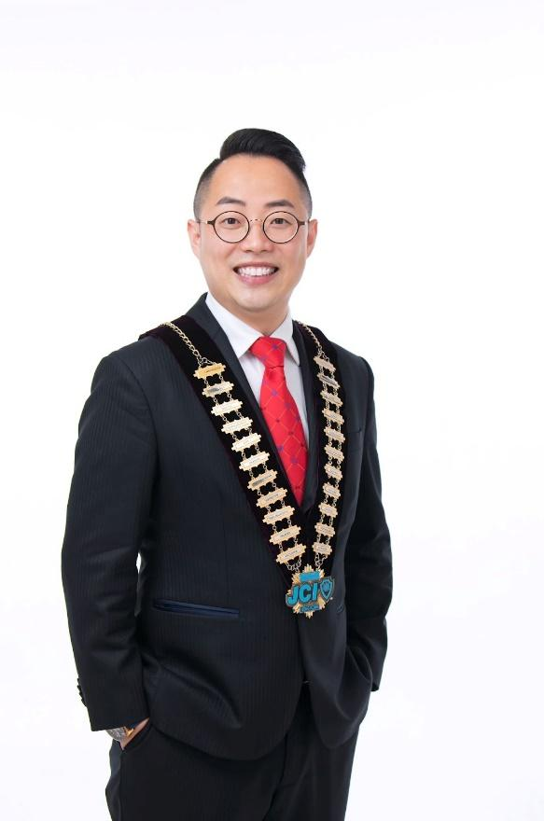

Senator Kenneth Yu

#### 

#### 3.4 JC Abbreviation

JCI Junior Chamber International

JCIHK Junior Chamber International Hong Kong

NOM National Organization Member

LOM Local Organization Member

ASPAC Asia Pacific Area Conference

APLLC Asian Pacific Lady LOM Council

|  |  |
| --- | --- |
| NP | National President |
| NIPP | National Immediate Past President |
| NGLC | National General Legal Counsel |
| NEVP | National Executive Vice President |
| NVP | National Vice President |
| NSG | National Secretary General |
| NHT | National Honorary Treasurer |
| NAEO | National Assigned Executive Officer |
| NBN | National Business network |
| TDC | Training & Developing Committee |
| IAC | International Affairs Commission |
| PRC | Public Relations Commission |
| MET | Major Emphasis Theme |
| SM | Senior Member |
| SMC | Senior Member Club |
| PM | Prospective Member |
| LRPC | Long Range Planning Committee |
| P | President |
| IPP | Immediate Past President |
| VP | Vice President |
| PA | Presidential Advisor |
| PP | Past President |
| CD | Community Development |
| YA | Youth Affairs |
| PR | Public Relations |

|  |  |
| --- | --- |
| MA | Membership Affairs |
| LD | Leadership Development |
| IA | International Affairs |
| BA | Business Affairs |
| R & R | Records & Recognition |
| LS | Leadership Seminar |
| EDP | Executive Development Program |
| TOYP | Ten Outstanding Young Persons |
| MFG | Monthly Fellowship Gathering |
| AGM | Annual General Meeting |
| EGM | Extraordinary General Meeting |

#### 3.5 Junior Chamber International Hong Kong 21 Chapters

|  |  |  |  |
| --- | --- | --- | --- |
| **NAME** | **AFFILATED**  **IN (YEAR)** | **SEX** | **OFFICIAL**  **LANGUAGE** |
| 1. JCI Victoria   維多利亞青年商會 | 1950 | M / F | Chinese / English |
| 1. JCI Kowloon   九龍青年商會 | 1965 | M / F | English |
| 1. JCI Island   港島青年商會 | 1966 | M | English |
| 1. JCI Peninsula   半島青年商會 | 1969 | M / F | Chinese |
| 1. JCI Hong Kong Jayceettes   香港女青年商會 | 1969 | F | English |
| 1. JCI Lion Rock   獅子山青年商會 | 1971 | M / F | Chinese |
| 1. JCI Harbour   海港青年商會 | 1977 | M / F | Chinese |
| 1. JCI Yuen Long   元朗青年商會 | 1977 | M / F | Chinese |
| 1. JCI Tai Ping Shan   太平山青年商會 | 1978 | M / F | Chinese |
| 10. JCI Bauhinia  紫荊青年商會 | 1979 | F | Chinese |
| 11. JCI Dragon  騰龍青年商會 | 1980 | M | English |

|  |  |  |  |
| --- | --- | --- | --- |
| 12. JCI East Kowloon  東九龍青年商會 | 1980 | M / F | English |
| 13. JCI City  城市青年商會 | 1981 | M | Chinese |
| 14. JCI Queensway  經緯青年商會 | 1984 | M / F | English |
| 15. JCI North District  北區青年商會 | 1985 | M / F | Chinese |
| 16. JCI Ocean  浩洋青年商會 | 1986 | M / F | Chinese |
| 17. JCI Sha Tin  沙田青年商會 | 1987 | M / F | English |
| 18. JCI Apex  晉峰青年商會 | 1994 | M / F | Mandarin |
| 19. JCI City Lady  城市女青年商會 | 2007 | F | Mandarin |
| 20. JCI Tsuen Wan  荃灣青年商會 | 2013 | M / F | English |
| 21. JCI Lantau  大嶼山青年商會 | 2016 | M / F | English |

### 4. Introduction of Junior Chamber International Queensway

### (JCI Queensway)

Junior Chamber International Queensway (經緯青年商會) is one of the 21 local chapters of

JCIHK. It was formed, for the first time in the history of HKJC, by a group of prospective members with the assistance of a few senior members in 1984. JCI Queensway is a mixed chapter using English as the official language.

Originally it is formed with the individuals from a variety of professions. It seeks to harness this diversity to create positive change. Over the years JCI Queensway has been actively involved in various projects with the aim of serving the community as well as providing training to its members. Now our aim targets at caring about the community, serving and rewarding the community.

JCI Queensway represents a network of highly motivated and forward-looking young people between the ages of 18 and 40 who come together to under a common mission: "to contribute to the advancement of the global community by providing the opportunity for young people to develop the leadership skills, social responsibility, entrepreneurship and fellowship necessary to create positive change". In addition, JCI Queensway provides opportunity for individual to excel in their personal development under the four areas: individual, community, international and business. Over the past twenty three years, JCI Queensway has been actively involved in various projects with the aim of serving the community as well as providing training to its members.

JCI Queensway provides opportunity for individual to excel in their personal development under the four areas: individual, community, international and business. Over the past eighteen years, JCI Queensway has been actively involved in various projects with the aim of serving the community as well as providing training to its members.

##### *Leadership Development (LD)*

Through various leadership training programs, members develop valuable skills such as goal setting, time-management, public speaking, parliamentary procedures, protocol, etc., thereby equipping them with necessary techniques to become future leaders of the community.

**Past Projects:**

Public Speaking Seminar and Contest, Officers Training Camp, Leadership

Development Program, Executive Development Program

##### *Community Development (CD)*

Through various community development programs, members identify social needs and issues, and develop projects to improve the well-being of the community. Awareness and sensitivity on community problems are thus enhanced.

**Past Projects:**

Fight Against Cyber Crime; Organic Farming; Tree Planting; Earth Day 2000 - Mistreated Batteries on Our Land;   
2014 Hubei Volunteer Education Program,   
2015 Seeing Hong Kong through Colorful Eyes,   
2017 CNY Charity FUNdraising Running,   
2017 Friendly Family Series: Listen, Connect and Accept  
2018 Friendly Family Series: Listen, Connect and Accept, Mental Health with心理衛生會  
2019 Friendly Family Series: Listen, Connect and Accept, Zentangle  
2020 LOVEMoji  
2021 Cultural Media – KOL Maker Cultural Heritage Ambassador   
2022 瑜心出發Grow & Glow Series – Queensway Wellness

##### *International Affairs (IA)*

Through a network of 200,000 Junior Chamber members in more than 100 countries around the world, members gain valuable international exposure, develop international friendship, and derive awareness on cross-border, cross-culture issues.

**Past Projects:**

China Environmental Prize Project; Junior Team Canada Exchange Forum International; Business Tour to Kuala Lumpur

**Sister Chapter:**

JCI Okinawa, Japan

JCI Kuala Lumpur Mandarin, Malaysia

**Friendly Associations:**

JCI Toyonaka, Japan

##### *Business Affairs (BA)*

Members can pursue personal business interests through the National Business Network as well as worldwide international networking activities. Each year, various business seminars and contact sessions are organized by the National Business Network.

**Past Projects:**

Huizhou Business Exchange Trip, Brand Marketing Seminar,

When JCI meets Asia Champion –“Evergrande”,

Be with you: Social Innovation Internship Program 2018  
2021 Extraordinary Brand Awards  
2022 Extraordinary Brand Awards

#### 4.1 Organization Chart of Junior Chamber International Queensway 2023

#### 4.2 Year Plan of Junior Chamber International Queensway 2022

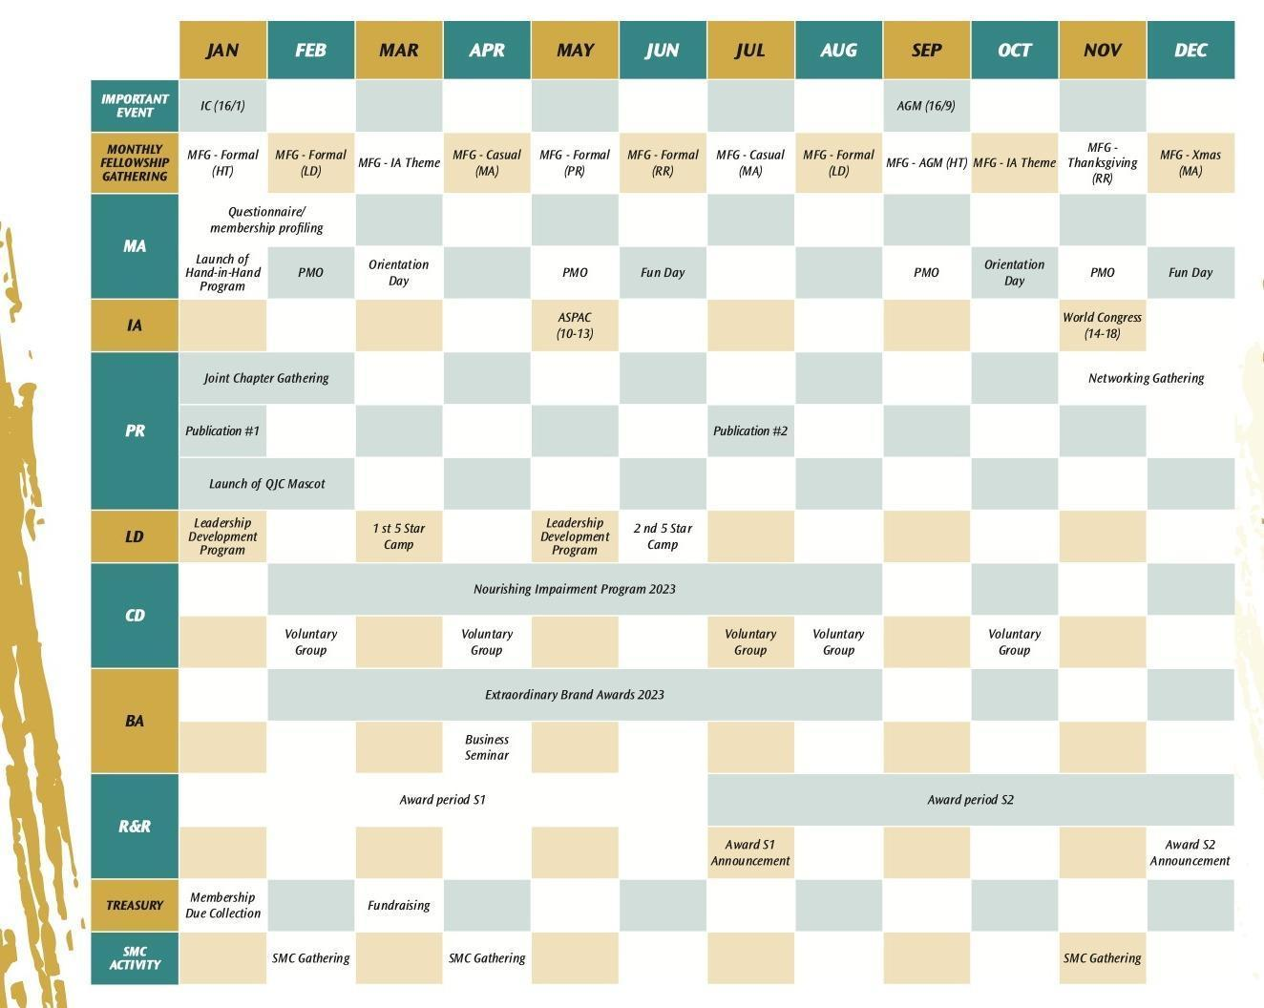

Please refer to the official website of JCI Queensway: <http://www.jciqueensway.org.hk/en/index.php>

#### 4.3 Past Presidents and Ex-NAEO of Junior Chamber International Queensway

|  |  |  |  |
| --- | --- | --- | --- |
| **Year of President** | **Name of President** | **NAEO** | **Remark on**  **NAEO** |
| Chapter President | Senator Rainbow Li | Senator Paul Cheung  (JCI City) | 1985 NP |
| 1990 National  President | Senator Larry Lau | Senator Paul Cheung  (JCI Peninsula) | 1986 NP |
| 1986 President | Sarita Lo | Valerie Cheung  (JCI Hong Kong Jayceettes) |  |
| 1987 President | Florence Tam | Senator Agnes Fok  (JCI Pan Mac) | From JCI  Macao |
| 1988 President | Senator Davis Kwong | Senator Connia Chu Lo  (JCI Hong Kong Jayceettes) |  |
| 1989 President | Senator Ivy Tam | Senator Wallace Yuen  (JCI Peninsula) |  |
| 1990 President | Senator Helen Yu | Senator Bassanio So  (JCI Dragon) |  |
| 1991 President | Susanna Au | Senator Ronald Ho  (JCI Victoria) | 1994 NP |
| 1992 President | Senator Anthony  Chan | Senator Raymond Yu  (JCI Harbor) | 1995 NP |
| 1993 President | Senator Amy Leung | Senator Justin Lui  (JCI Apex) | 1996 NP |
| 1994 President | Senator Iris Chan | C.K. Lee  (JCI Kowloon) |  |
| 1995 President | Senator  Jean-Francois Arnold | Senator Mary Au-yeung  (JCI Apex) |  |
| 1996 President | Roland Chan | Senator Wendy Pang  (JCI Tai Ping Shan) |  |
| 1997 President | Alexander Wong | Senator Louise Chan  (JCI Peninsula) | 1999 NP |

|  |  |  |  |
| --- | --- | --- | --- |
| 1998 President | Senator William Kwan | Senator Arthur Lui (JCI Dragon) |  |
| 1999 President |  | Senator Andrea Suen  (JCI Lion Rock) |  |
| 2000 President | Clara Cheng | Senator Ellen Tsang  (JCI Lion Rock) | 2005 NP |
| 2001 President | Ronald Chung | Cecilia Cheung  (JCI North District) |  |
| 2002 President | Nini Chia | Senator Judith Tam  (JCI Harbor) |  |
| 2003 President | Senator Athena Chung  (JCI Harbor) |  |
| 2004 President | Alex Liu | Senator Yury Lam  (JCI Kowloon) |  |
| 2005 President | Adam Siu | Senator Andy Lam  (JCI Dragon) |  |
| 2006 President | Ken Chung | Eva Lau  (JCI Bauhinia) |  |
| 2007 President | Senator Connie Chan | Senator Gene Tang  (JCI Peninsula) | 2010 NP |
| 2008 President | Senator John Ng | Senator Raymond Lee  (JCI City) |  |
| 2009 President | Senator Parlett Chang | Senator Kristine Chung  (JCI Ocean) |  |
| 2010 President | Jeffrey Yip | Senator Franco Cheung  (JCI Peninsula) |  |
| 2011 President | Lincoln Li | Senator Frances Cheung  (JCI Lion Rock) |  |
| 2012 President | Veronica Ji | Senator Jennifer Lam  (JCI Hong Kong Jaycettes) |  |
| 2013 President | Senator Leo Ng | Senator Ronald Kan  (JCI Sha Tin) | 2018 NP |
| 2014 President | Suki Cheung | Senator Zenith Lin  (JCI Dragon) | 2019 NP |

|  |  |  |  |
| --- | --- | --- | --- |
| 2015 President | Senator Man Fok | Senator Pokit Lok  (JCI City) |  |
| 2016 President | Ray Tam | Senator Winston Lin  (JCI City) |  |
| 2017 President | Terry Chan | Senator Jessica Lee  (JCI East Kowloon) |  |
| 2018 President | Campbell Ting | Senator Victor Lam  (JCI Ocean) |  |
| 2019 President | Athena Siu | Senator Gary Ngan  (JCI Dragon) |  |
| 2020 President | Samuel Chan | Thomas Wong  (JCI Lion Rock) |  |
| 2021 President | Lucy Jiang | Freddy Tse  (JCI North District) |  |
| 2022 President | Jesty Cheung | Senator Rosanna Wong  (JCI Hong Kong Jayceettes) |  |
| 2023 President | Heidi Chong | Evan Leung  (JCI Kowloon) |  |

#### 4.4 2023 President

Heidi Chong is 2023 President of JCI Queensway.

### 5. JCI Queensway Member Guides

#### 5.1 How to become a member?

Junior Chamber International Queensway is an association of young men and women between the ages 18 and 40 who have a desire for self-development and wants to make an impact on their community and who want to socialize and network with other young people, our membership application is open to young persons between ages of 18 to 40.

To become a Full Member of JCI Queensway, Prospective Members need to:

Mandatory (All requirements must be completed)

✔ **Attend the Induction Ceremony**

✔ **Pay annual membership due**

✔ **Be able to recite the JC Creed, Mission and Vision**

✔ **Go through an interview/examination by board members**

✔ **Serve as an Organizing Committee member for one project**

✔ **Attend one Monthly Fellowship Gathering (MFG)**

✔ **Attend one Prospective Member Orientation (PMO)**

By completing the above activities, a great step has been taken by learning about the Junior Chamber and becoming an active and productive member. We would congratulate our prospective members becoming our full members!

#### 5.2 Members Career Plan

|  |
| --- |
| **JCI Career Path**  **JCI**  **NOM**  **LOM** |

|  |
| --- |
| **LOM**  **LOM President**  **Excom Members (Executive Vice President, Vice President,  Honorary Secretary, Honorary Treasurer)**  **Directors**  **Officers** |
| **NOM**  **National President**  **National General Legal Counsel**  **National Executive Vice Presidents**  **National Vice-Presidents**  **National Secretary General**  **National Honorary Treasurer**  **National Directors**  **National Officers** |
| **JCI**  **JCI President**  **Legal Counsel**  **Executive Vice Presidents**  **Vice Presidents**  **Treasurer**  **Secretary General**  **Special Assistants to JCI President**  **Executive Assistants**  **Representatives to International Organizations** |

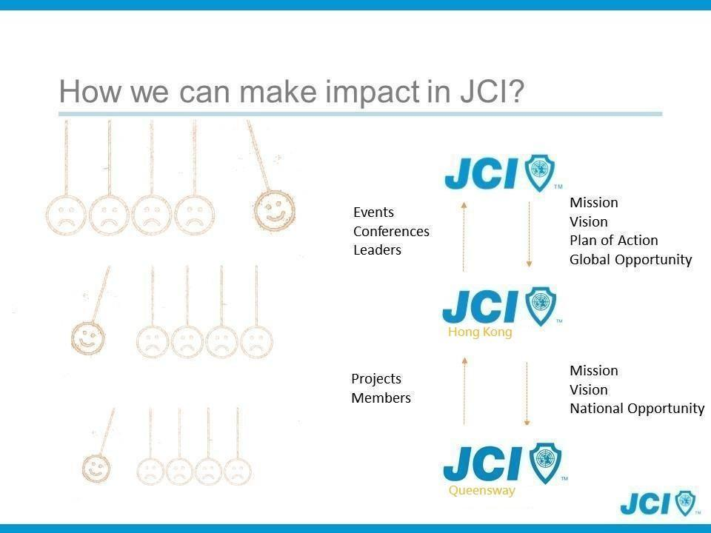

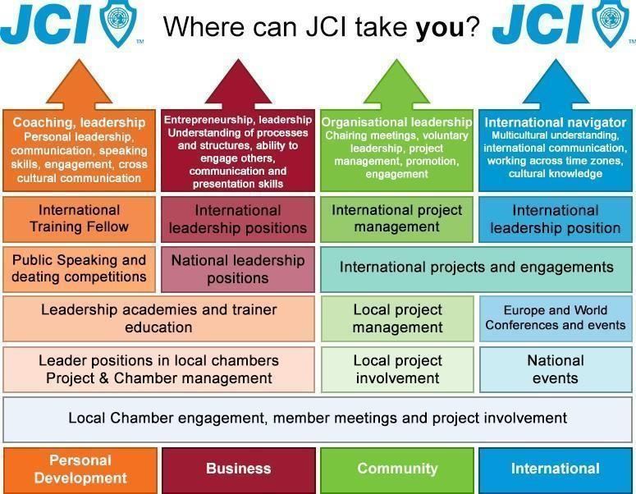

**JCIHK Power Learning Path 2023**To recognize and encourage our JCIHK members for their active and continuous learning in JCI, National Training & Development Commission (NTDC) has launched the “Power Learning Path 2023 - Learning As A Leader”.

There will be four levels of recognition in the program. It is required to achieve all lower levels before reaching the higher ones.

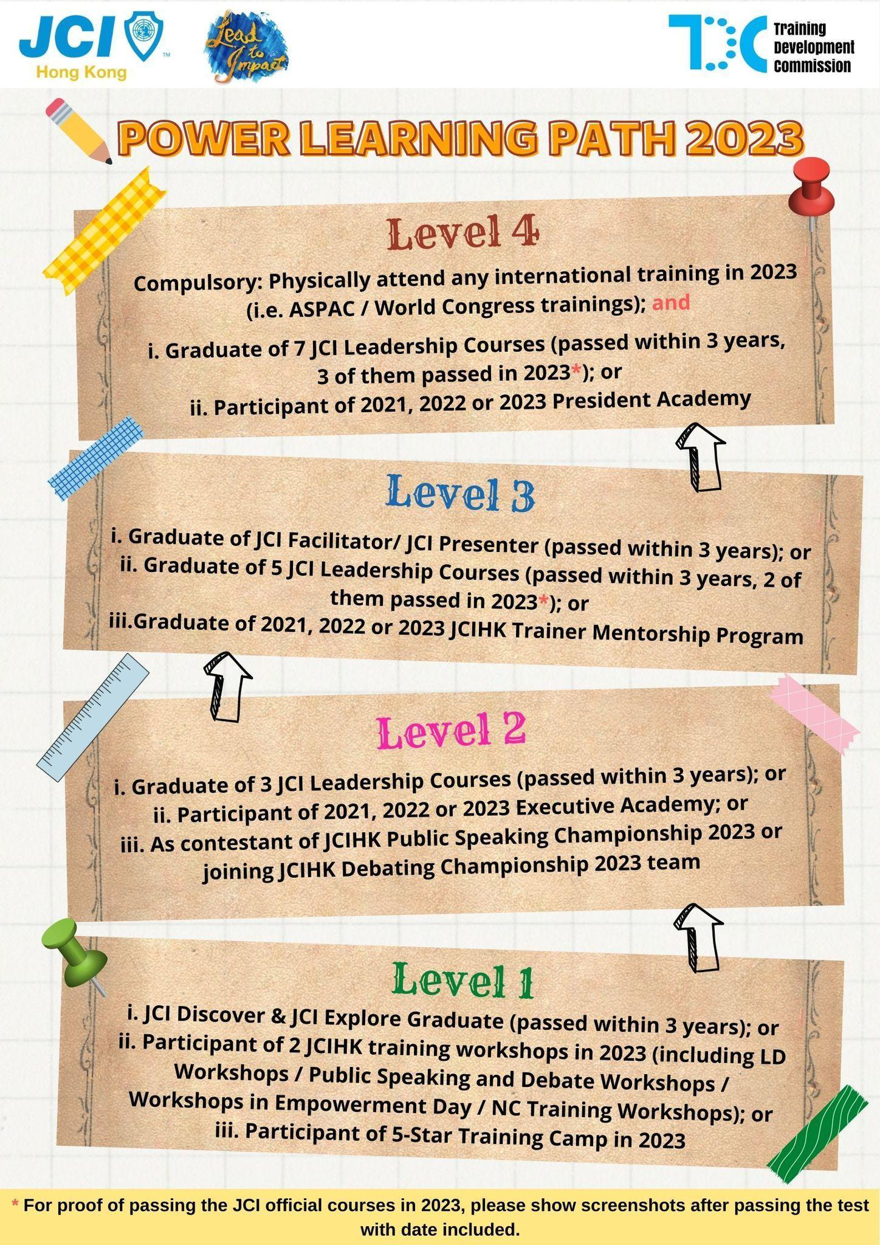

**JCI Action Framework**

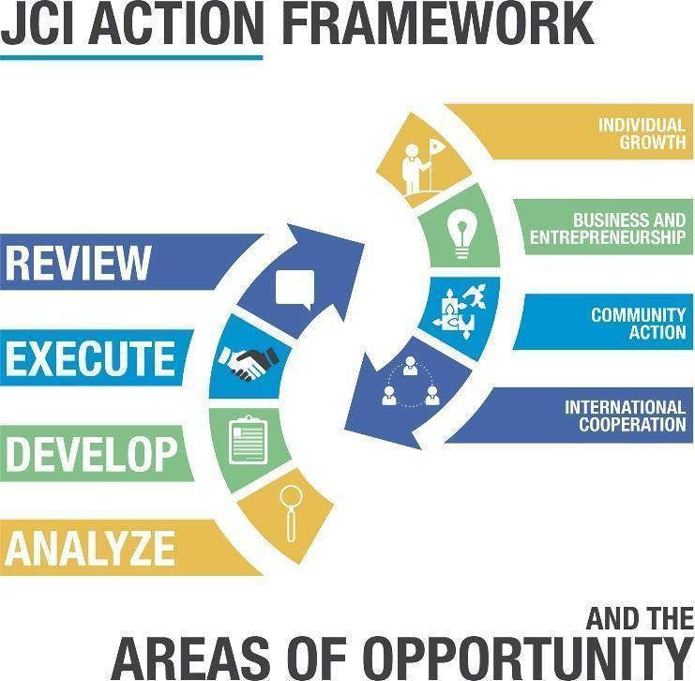

**JCI RISE**Objective: JCI RISE (Rebuild, Invest, Sustain, Evolve) aims to motivate JCI members to secure and bolster economic opportunities at the local, national and world-wide levels.

RISE is JCI’s reaction to the Covid-19 pandemic from an economic perspective. It’s a member-driven initiative, encouraging members to develop projects related to the three pillars of RISE:

Sustaining and rebuilding economies by supporting small, local businesses

Motivating the workforce through youth entrepreneurship

Preserving mental health and well-being

This initiative anchors JCI in economic reality, while enabling our global members to move towards One Future.

We need to be active agents of positive change by standing up, supporting and also leading our communities to be better.

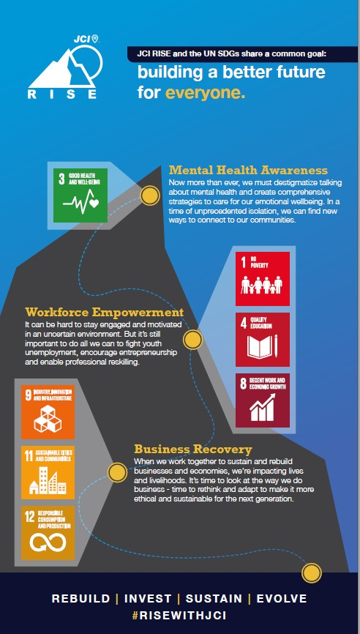

#### 5.3 Quick Manual on Member’s QJC Mail Set-up

**Step 1:**

When you receive your **account of @jciqueensway.org.hk** by JCI Queensway Secretary, you can first login into your Gmail account.

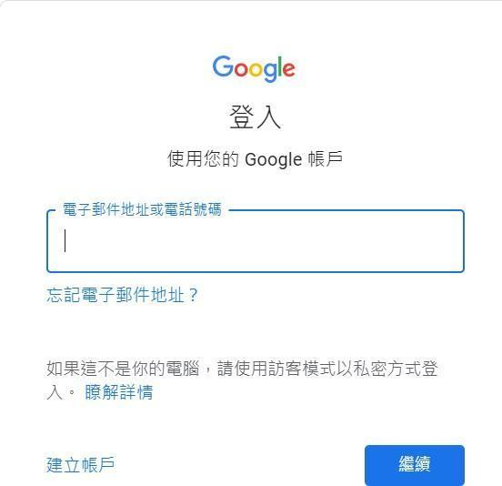

**Step 2:**

After logging into your Gmail account, you can **click into “**查看所有設定**”**, as indicated by the picture below.

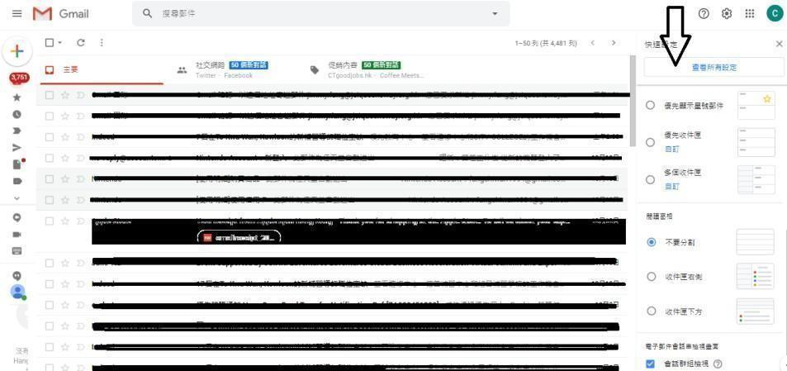

“

**Step 3:**

Afterwards, you can **click into the setting of “**帳戶和匯入**”**, as shown in the picture below.

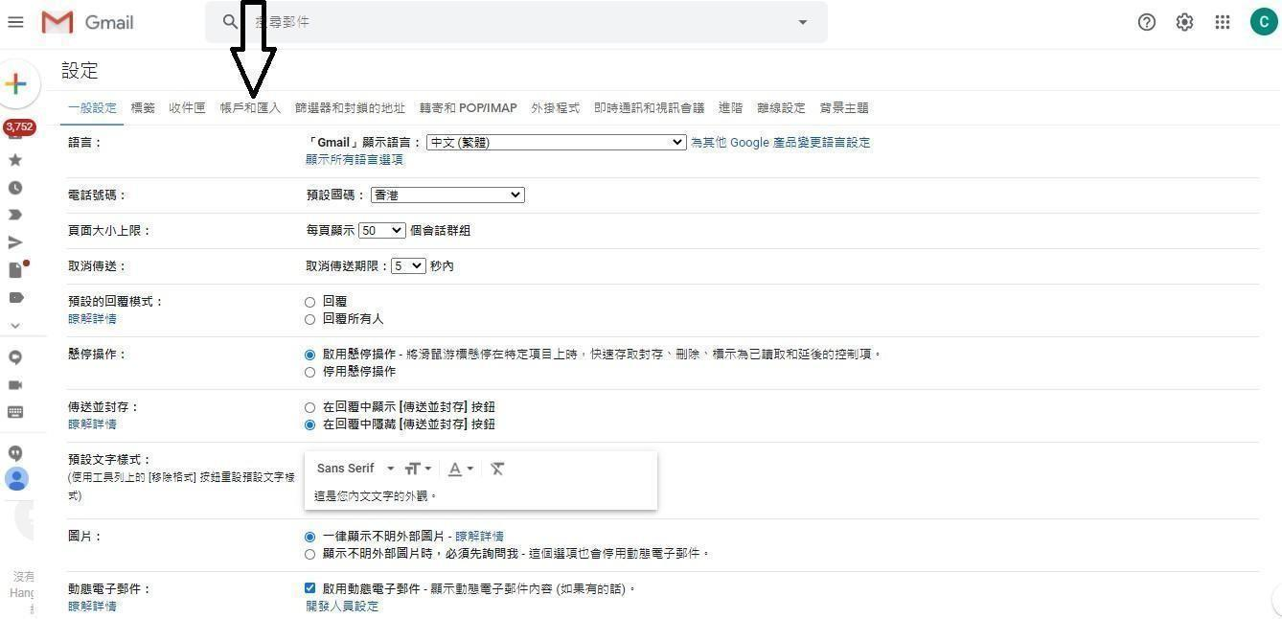

**Step 4:**

You can **click “**新增另一個電子郵件地址”under the column of “選擇寄件電郵” as indicated by the arrow below.

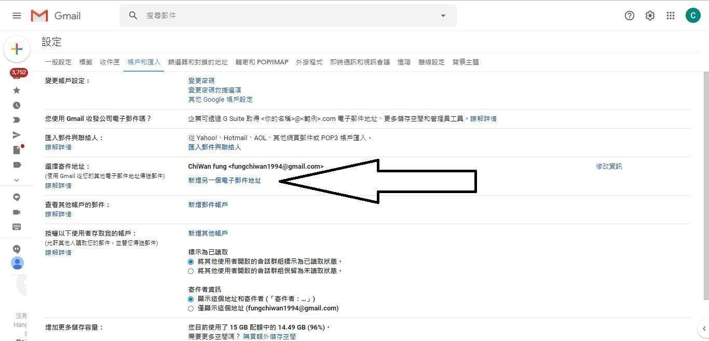

**Step 5:**

After clicking into the button of **“**新增另一個電子郵件地址”, the setting page will be shown as the picture below. Your name has been set up, and the only way you have to do is to **insert your account of @jciqueensway.org.hk into the column of “**電子郵件地址**”.** Then you can click “下一步” and go to next page.

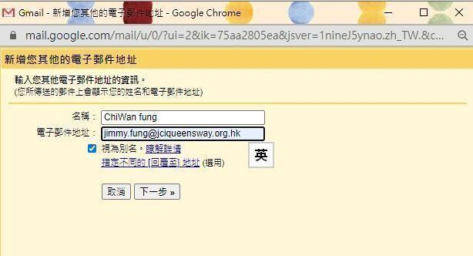

**Step 6:**

Then you can set up your gmail to send out email using your QJC account by the setting as below:

**Password = qjc840414 Port = 25 Select unsecured connection**

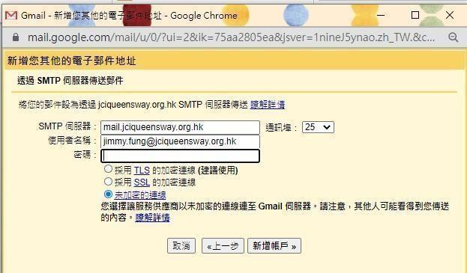

After the completion of the above setting, you can **select “**新增帳戶**”.**

**Step 7:**

You will **receive the password from your gmail for verification,** and put it to the space as below.

After inserting your password, you can click “驗證”.

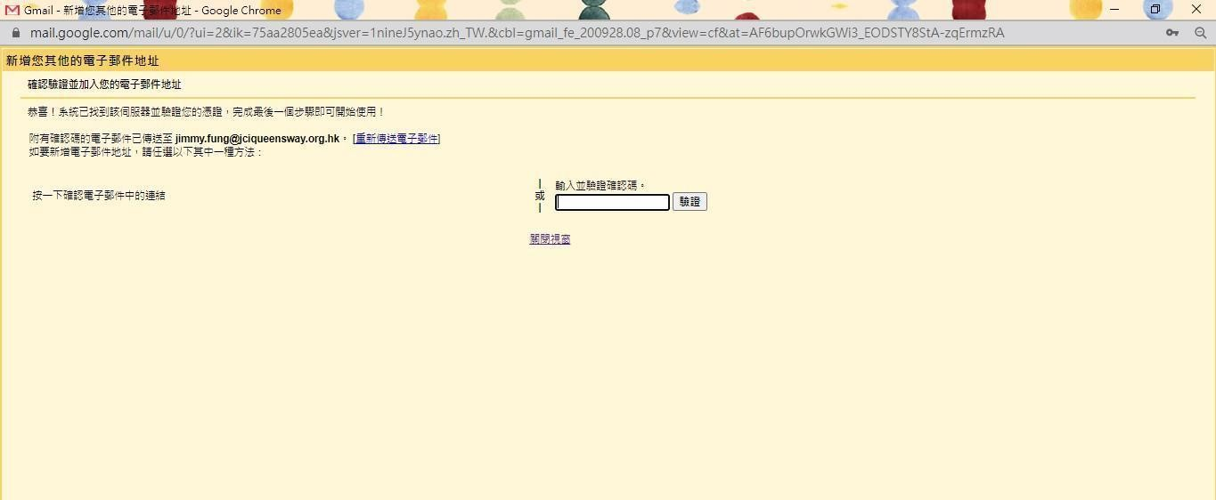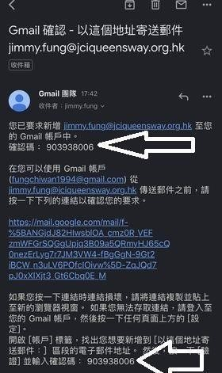

**Step 8:**

Finally, your gmail can be successfully connected with your QJC account. You can refer to the picture as below for the confirmation of connecting your gmail account and QJC account. You can send email by QJC mail.

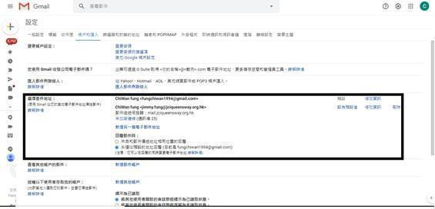

#### 

#### 5.4 JCI Queensway and JCIHK Calendar Subscription Quick Manual

**Step 1** Open your Google Calendar in your browser and log in if you haven't already.

##### Step 2 At the bottom-left, there should be a section titled "Other calendars." Click the plus symbol (+) next to this title.

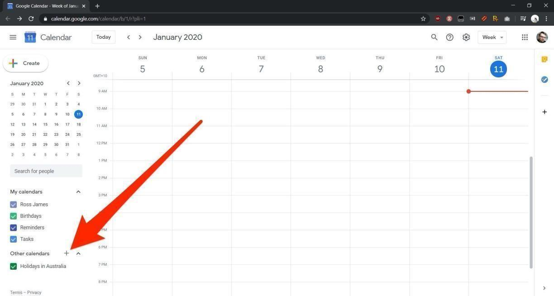

Google Calendar will work in any major browser, as long as you have an email registered with Google.41

**Step 3**

Select "Subscribe to calendar" from the pop-up menu.

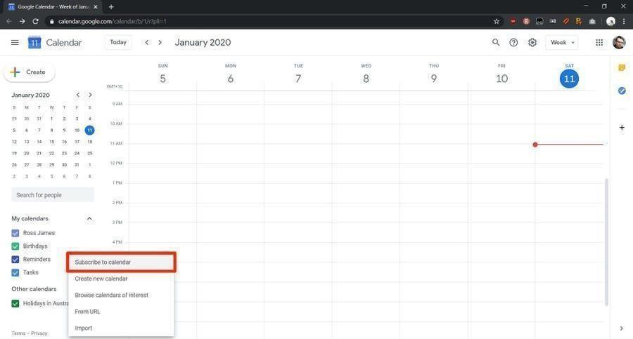

**Step 4**

You will be brought to a new screen that is entirely blank except for a search bar labeled "Add calendar." Click this search bar and enter QJC email addresses into the field, and then hit the "Enter" or "Return" key on your keyboard.

**QJC’s Calendar:**

* qjcsecretariat@gmail.com

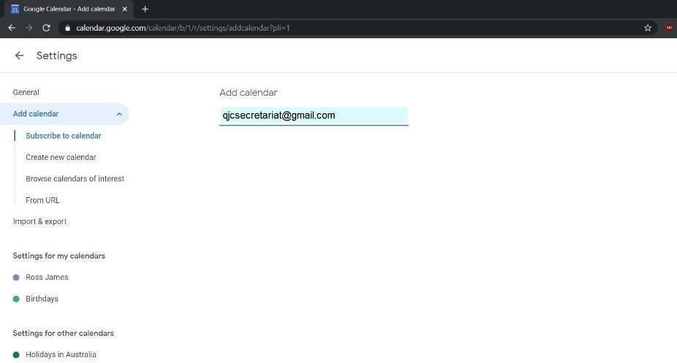

Type the above email addresses into the text field to request access to QJC’s calendar.

**Step 5:**

If you have been given the URL of a shared calendar from NOM and LON, instead select "From URL" on the toolbar to the left and enter it into the text field of this menu.

* **NOM Calendar:**

calendar.google.com/calendar/ical/jcihk.calendar%40gmail.com/public/basic.ics

- **LOM Calendar:**

calendar.google.com/calendar/ical/jcihklom%40gmail.com/public/basic.ics

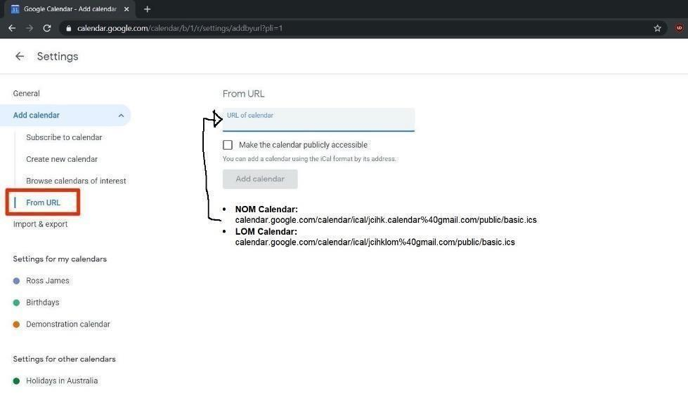

Enter the URL of a shared calendar into this text field.

### 6. Project Guides

#### 6.1 Duties of Organizing Committee (OC)

###### Supervising Officer

* A liaison person between NOM/LOM and OC
* Assist the Committee Chairman in setting up the OC Ensure proper functioning of OC
* Advice Chairman and the Committee on all matters concerning the project

###### Chairman

* To be appointed by the Board of Directors
* Conduct OC meetings in a fair and proper manner appoint OC members in the 1st meeting
* Oversee execution of the project / task
* Allocate jobs among committee members, manage and supervising the committee ∙ Prepare project proposal, job description and project manual
* Notes down detail of project which will be helpful to other chairmen in planning similar project in the future

###### Deputy Chairman

* He / She is expected to be capable of sitting in for the Chairman is his / her absence to conduct all businesses on his / her behalf. He / She ought to have qualities similar to that required of a Chairman although provision would be given to lack of experience.

###### Secretary

* Arrange meeting venue and call up meeting
* Prepare minutes and agenda which are to be sent to all committee members before meeting
* Prepare an attendance record and contact list in the 1st OC meeting ∙ Copy letter / minutes / agenda to supervisors, e.g. President, Supervising, VP, and Directors & LOM Hon. Secretary
* Prepare and sent out correspondence which are to be signed by Project Chairman / President
* Compile a project file within one month after completion of the project and hand to the LOM / NOM

###### Treasurer

* Prepare a budget which is to be moved for adoption in the 1st OC Meeting in some cases, assist to solicit sponsorship for organizing committee control on the financial expenditure to in line with the budget
* Cash all cheques once received in order to avoid bounce cheques ∙ Keep account record and cash receipts, and liaise with Chapter's Honor Treasury on expenditure projection
* Prepare an income & expenditure statement which is to be moved for adoption in the evaluation meeting

###### Promotion

* Design promotional means: campaign, circular, advertisement, telephone contact, etc ∙ Design promotional material: circular to HKJC members, and public as well
* Arrange promotion presentation in different LOM Monthly Fellowship Gatherings (MFGs) ∙ For some large-scale CD / IA projects, liaise with mass media and arrange press conference and prepare press release / press kit
* Being the contact person for enquiry

###### Registration

* Contact relevant LOM Directors for their LOM's attendance collect reply slips from participants
* Prepare registration forms and guest recognition list being the contact person for enquiry
* Work jointly with treasury concerning collection of registration fees from the participants

###### Logistics

* Arrange for corsage, banner, name stands and trophy / souvenir flat / souvenir gift for guest speakers.
* Prepare a logistics checklist and arrange necessary equipment for event day use
* Prepare a floor plan, seating arrangement and make floor arrangement on event date
* Arrange photo / video taking on event day and the development of film book venue and arrange transport

###### Program

* Design a program
* Prepare a program rundown of the event day
* Prepare a program / participant’s handbook and evaluation forms for the distribution to all participants Contact with speaker / guest of honour to confirm details of program and liaise with logistics OC on speakers need

## 6.2 Parliamentary Procedures

# A. Conduct of Meeting

1. At the exact hour named or as soon thereafter as a quorum is present, the Chairman shall call the meeting to order. If the Chairman is not present, the Vice Chairman shall take the chair. If no Vice-Chairman is present, the members present shall elect one of themselves to preside. If no quorum is present within 30 minutes of the time appointed the meeting shall be adjourned to the same time and place one week later or such other date as the Chairman may decide.
2. The Secretary shall record the names of members and guests present and apologies for absence.

1. The meeting shall adopt the minutes of the last meeting (if any), amending them if necessary.

1. Business (if any) arising from the minutes of the last meeting shall be discussed.

1. The CHAIRMAN shall make his report.

1. The secretary's report and report on correspondence received shall be made and discussed if necessary.

1. Any other reports (sub-committees, etc.) shall be put before the Committee for consideration.

1. Old or unfinished business previously discussed for this meeting shall be taken up again.

1. New business placed on Agenda by the Chairman shall be introduced and discussed.

1. Any other business.

1. When all the business is concluded the Chairman declares the meeting closed with statement of date, time and Place of next meeting.

# B. Agenda

Prior to every meeting the Chairman will prepare and distribute an agenda setting out a list of matters to be discussed in the order in which they will be discussed at the meeting.

# C. Rules of Procedure

(a) Obtaining the Floor

* Before anyone can make a motion, they must obtain the floor.
* This is accomplished as soon as the floor has been yielded by the previous speaker (if any) by addressing the chair, "Mr. Chairman".
* Addressing the chairman before the floor has been yielded by the previous speaker does not give precedence.
* When more than one person addresses the chair at the same time, the chairman will recognize one who seems to the chairman to be most entitled. ∙ A person who has not spoken shall have precedence over one who has already spoken on the subject presently being discussed.
* In the case of a disagreement with the choice made, two members may appeal by motion, moved and seconded. The Chairman then calls for a vote.
* Having assigned the floor, it then becomes chairman's duty to protect the speaker from interruptions from other members. Interruption are only permitted under certain circumstances namely, Point of Order, Question of Privilege,
* Request that Motion be divided and, subject to the Speaker's consent, Point of Information. After the interruption the floor is given back to the original speaker.

(b) Motion

* Before any matter may be discussed at a meeting it must be submitted in the form of a motion which is moved by one member and seconded by another. ∙ A motion is made by a member obtaining the floor and addressing the chair by stating, I move that ..." or similar words.
* The Chairman repeats motion and asks for a seconder. If it seconded it is then debatable and may be accepted, amended withdrawn and rejected.
* When a motion has been adopted, it becomes a resolution.
* If there is no seconder the chairman shall declare that the motion dies for lack of a seconder and proceed to the next order of business**.**

(c) Privileged Motions

* Take precedence over all others but are only privileged motions when made while another question is pending i.e., before the Committee. In order of precedence, they are:
  + 1. To fix time to adjourn;
    2. To adjourn;
    3. To take recess;
    4. To raise question of privilege, or point of order or dividing motion. (d) Amendments
* Amendments to a motion may be proposed at any time during the discussion.
* All amendments must be formally proposed and seconded and are subject to the same rules as motions.
* No amendment may be entertained which has the effect of nullifying the main motion.
* Any amendment must be relevant to the subject matter of the motion and may be amended in only one of three ways:
  + 1. By leaving out certain words;
    2. By adding certain word; or
    3. By deleting certain words and replacing them by others.
* Not more than two amendments may be before the meeting at one time. As soon as one amendment has been accepted or rejected, another may be proposed.
* No amendment can be proposed which is the same in purpose to one that has already been accepted or defeated.

(d) Notice of Motion

* Advance notice of certain motions is sometimes required by a constitution or by-laws. In such cases, members must be advised in writing, prescribed number of days in advance of motion.

(e) Withdrawal or Motion or Amendments

* A member may with the consent of the seconder withdraw his own motion or amendment
* However, no motion or amendment can be withdrawn whilst there is a subsequent amendment in existence or after it has been voted upon passed.

(f) Voting

* Voting on motions and amendment is in the reverse of the order in which they are made i.e.
  + 1. On the amendment to the amendment, or the second amendment;
    2. On the amendment;
    3. On the motion or the motion as amended.

· Voting shall be by a show of hands or by ballot (as provided in the next rule) each member present having one vote.

(g) Ballot

* The ballot is a secret vote designed to save members from embarrassment. It is to be used when the constitution or by-laws require it or when requested by any one member present at the meeting.

(h) Deciding Vote

* The chairman does not vote except in the case of a tie when he shall have a casting or deciding vote. This applies to a Ballot as well as an ordinary privilege".

1. Rejected Motion

* A rejected motion shall not come up again during same Jaycee year unless at least two-third of the members present approve of a motion "That the question be reconsidered". This motion is not debatable and calls for immediate vote.

1. The Point of Order

* A speaker may be interrupted for a Point of Order. If a member feels that improper language has been used, irrelevant argument introduced, or a rule of procedure broken, he is entitled to "rise to a point of order" and interrupt the speaker.
* The point of order must be stated definitely and concisely.
* The Chairman shall decide the point without debate though he may ask opinions.
* He shall not give any reasons for his decision but just his decision. ∙ After he has given his decision, his ruling may be appealed by the member when the chairman will state his decision and the point of appeal, then puts the question which is not debatable: "shall the decision of the Chair stand as the judgment of this meeting?"
* A simple majority determines the issue.
* This merely settles a point of procedure and NOT a vote of confidence in the Chairman.

1. Question of a Privilege

* If a member feels that his' own or the organization’s reputation or position is endangered, he is entitled to raise a "question of privilege".
* Procedure is the same as for a point of order.

1. Motion be divided

* If a member is of the opinion that a motion ought to be considered in separate parts and not as one whole he can move that the Motion be Divided.
* A Speaker may be interrupted for this purpose and an immediate vote shall be taken with discussion.
* If the Motion to divide the motion being discussed is passed, the meeting must then discuss the separate parts of the Motion and vote on them separately. ∙ When moving that the motion be divided the member so doing must specify in what ways the Motion is to be divided.

1. Questions

* With the consent of the speaker, he may be interrupted for a question put by another member.

1. Quorum

* A quorum is the minimum number of members who must be present at a meeting to make proceedings valid.
* Without a quorum no business may be transacted

1. To Table a Motion

* To adjourn discussion of a main motion which is before the meeting either indefinitely or to a fixed date is "To table a motion".
* It requires another motion which is not debatable, and which requires only a simple majority.
* If the motion is to table only until a particular time, it is debatable as to time only.
* If carried, the main motion in question comes up automatically at the time appointed, or if indefinite as to time, it remains tabled until such time as another motion (not debatable) "That the former one is now reconsidered" is passed by a simple majority.
* When the main motion comes back for consideration the debate will continue on the main motion as in the same condition that it was tabled, (including amendments, etc.)

1. Irrelevant Remarks

* Irrelevant remarks shall be stopped immediately by the chairman.
* A person who has already spoken on the question shall not be allowed to speak again until all those desiring to speak have been heard.
* Only one speaker may have the floor at a time.
* No one may speak until he has been given the floor by the chairman. ∙ Every speaker must address his remarks to the Chair and not to the meeting.

1. Previous Question

* The previous question is the demand for an immediate vote on a motion or amendment.
* The motion "that the question be now put" is moved and seconded in the ordinary way.
* It is not debatable and requires a two-thirds affirmative vote.
* If it is passed there can be no further discussion on the main motion, except that its mover may close the debate before the final vote is taken.
* If rejected, the discussion continues.
* If a subsequent amendment is under discussion, it must be disposed of before the Previous Question may be moved.

(r) Adjournment

* A motion to adjourn or recess may be moved at any time.
* It is not debatable except if it is sought to adjourn to a time when discussion is permitted on that point only.
* The motion requires a simple majority and, if passed, the meeting ends; if rejected the business continues.

General

* If these rules are silent as to any particular matter, it is for the meeting itself to decide the point.

# D Standard Format of OC Meeting Agenda

**(a) Standard Format for 1st OC Meeting Agenda**

##### (Chapter Name) (Project Name)

NOTICE IS HEREBY GIVEN THAT the 1st Organizing Committee Meeting will be held on (Date) at (Time) at (Place).

###### A G E N D A

1. Meeting Call to Order
2. Recital of JCI Creed, Mission and Vision
3. Recognition of Guests
4. Appointment of Recording Secretary
5. Adoption of Agenda
6. Briefing by Supervising Officer
7. Appointment of Organizing Committee and Assignment of Duties
   1. Hon. Secretary
   2. Hon. Treasurer
   3. Promotion
   4. Registration
   5. Logistics
   6. Programme
8. Establishment of Voting Strength
9. Report from Chairman
10. Any Other Business
11. Remarks by Supervising Officer
12. Remarks by Advisor
13. Remarks by Guest
14. Date, Time and Place of Next Meeting
15. Adjournment

Name

Project Chairman

**(b) Standard Format for OC Meeting Agenda**

##### (Chapter Name) (Project Name)

NOTICE IS HEREBY GIVEN THAT the (Sequence) Organizing Committee Meeting will be held on (Date) at (Time) at (Place).

###### A G E N D A

1. Meeting Call to Order
2. Recital of JCI Creed
3. Recognition of Guests
4. Establishment of Voting Strength
5. Adoption of Agenda
6. Adoption of Minutes of Last Meeting
7. Matters Arising from Minutes of Last Meeting
8. Report from Chairman
9. Report from Organizing Committee
   1. Hon. Secretary
   2. Hon. Treasurer
   3. Promotion
   4. Registration
   5. Logistics
   6. Programme
10. Any Other Business
11. Remarks by Supervising Officer
12. Remarks by Advisor
13. Remarks by Guest
14. Date, Time and Place of Next Meeting
15. Adjournment

Name Name

Project Chairman Honorary Secretary

**(c) Standard Format for OC Evaluation Meeting Agenda**

##### (Chapter Name) (Project Name)

NOTICE IS HEREBY GIVEN THAT the Organizing Committee Evaluation Meeting will be held on (Date) at (Time) at (Place).

###### A G E N D A

1. Meeting Call to Order
2. Recital of JCI Creed
3. Recognition of Guests
4. Establishment of Voting Strength
5. Adoption of Agenda
6. Adoption of Minutes of Last Meeting
7. Matters Arising from Minutes of Last Meeting
8. Report from Chairman
9. Report from Organizing Committee
   1. Hon. Secretary
   2. Hon. Treasurer
   3. Promotion
   4. Registration
   5. Logistics
   6. Programme
10. Overall Evaluation and Adoption of Income and Expenditure
11. Any Other Business
12. Remarks by Supervising Officer
13. Remarks by Advisor
14. Remarks by Guest
15. Dissolution of Organizing Committee
16. Adjournment

Name Name

Project Chairman Honorary

Secretary

# E. Standard Format of OC Meeting Minutes

##### (Chapter Name) (Project Name)

Minutes of (Sequence) Organizing Committee Meeting held on (Date) at (Time) at (Place).

|  |  |  |
| --- | --- | --- |
| **Present:**  Person 1 | name | Chairperson |
| Person 2 | name | Secretary |
| Person 3 | name | Treasurer |
| Person 4 | name | Program |
| Person 5 | name | Promotion |

**Absent with apologies:**

|  |  |  |
| --- | --- | --- |
| Person 2 | name | (Position) |
| Person 3 | name | (Position) |
| Person 4 | name | (Position) |

**Attend:**

Person1 name President

Person2 name Supervising Officer

1. Meeting call to order The meeting was called to order at HH:MM p.m.
2. Recital of JCI Creed

Chairperson lead OC members to recite the JCI Creed

1. Recognition of Guests

Chairman recognized the attendance of Guest

1. Establishment of Voting Strength Total Voting Strength:_________________

Simple Majority:_______________Two-third Majority: ___________

1. Adoption of Agenda

Person2 moved to adopt the agenda, (OC) seconded. No amendment was made. (Motion Carried)

1. Adoption of Minutes of Last Meeting

Person2 moved to adopt the minutes of last meeting, (OC) seconded. No amendment was made. (Motion Carried)

1. Matters Arising from Minutes of Last Meeting
2. Report by Chairman
3. Report from Organizing Committee

9.1. Report by Secretary

[The matter mentioned should be printed here point by point]

9.2. Report by Treasurer

[The matter mentioned should be printed here point by point]

9.3. Report by Promotion

[The matter mentioned should be printed here point by point]

9.4. Report by Registration

[The matter mentioned should be printed here point by point]

9.5. Report by Logistics

[The matter mentioned should be printed here point by point]

9.6. Report by Programme

[The matter mentioned should be printed here point by point]

1. Any Other Business

[The matter mentioned should be printed here point by point]

1. Remarks by Supervising Officer
2. Remarks by Advisor
3. Remarks by Guest
4. Date, Time and Place of Next Meeting
5. Adjournment

The meeting was adjourned at (Time). Second by ()

|  |  |
| --- | --- |
| Name | Name |
| Project Chairman | Honorary Secretary |

# F. Standard Format of OC Report

(Chapter Name) (Project Name)

OC Meeting Report

Meeting Date : __________________________Agenda No. :

Name :____________________________________Position : ______________________

1. Report and Highlight:

1. Work Done:

1. Action Plan:

1. Discussion:

1. Motion:

1. Attachments:



**Junior Chamber International**

**Queensway 21/F, Seaview commercial Building,**

**21-24 Connaught Road, West, Hong Kong**

**Tel: 25438913 Fax: 2543 6271** [**http://www.jciqueensway.org.hk**](http://www.jciqueensway.org.hk/)